Ably dynamic Notification Step

Objective

Ably organizes real time data (messages) within applications into named channels that are the “unit” of distribution. Every message published on a channel by a REST or Realtime client is broadcast by Ably to all realtime subscribers on that channel. This scalable and resilient messaging pattern is commonly called pub/sub.

UI

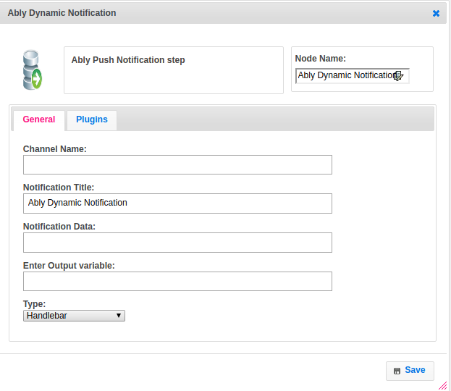

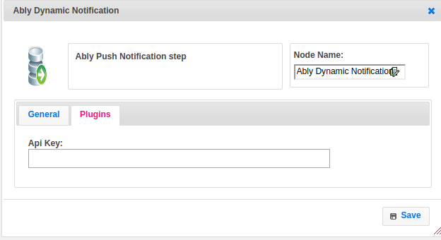

## Attributes

|  |  |
| --- | --- |
| **Attributes** | **Description** |
| **1. Channel Name** | Channels are the medium through which messages are distributed; clients attach to channels to subscribe to messages, and every message published to a unique channel is broadcast by Ably to all subscribers |
| **2. Notification Title** | The title for the notification data to publish into channel |
| **3.Notification Data** | Data published through the Ably platform is packaged in a message. Each message contains, amongst other things, an optional event name, data payload and an Ably generated unique ID. |
| **4.Type** | To select type as free marker template or handlebar |
| **5. Api_key** | Ably can has one or more private API keys that you set up and configure via the dashboard. These keys can be used to authenticate with Ably. It is recommended that private API keys are never shared with untrusted parties, and as such, should only be used by your trusted secure servers when authenticating with Ably. |
| **5. Output Variable** | Used to store the response of the request. |

## Executor Description

In executor class first create a json object to send notification body data and send notification to the respective channel with message data and it will send the status based on response code. If any exception occur then set status to failure.

## Difference between Ably Dynamic step and Ably Notification step

We need not to provide the plugin details separately. In dynamic step this field are there.

When developer wants to give the plugin details dynamically then the appup suggest them to use the ably dynamic step.

## Resource

## For more information please refer the below link

<https://www.ably.io/documentation>